QR factorization
Any n x n real matrix can be written as A=QR, where Q is orthogonal and R is upper triangular. To obtain Q and R, we use the Householder transformation as follows:
Let P₁, P₂, …P_{n-1}, be matrices such that 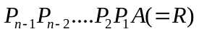 is upper triangular. These matrices may be chosen as orthogonal matrices and are known as householder matrices. Then we will have the required factorization with 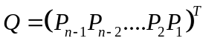
We first find P₁ such that P₁A will have all elements below the diagonal in the first column as zero. We would then find P₂ such that P₂P₁A will have all zeroes below the diagonal in both the first and the second column. And so on till we find P_{n-1} which produces the upper triangular matrix. The procedure is as follows:
(illustrated for a 3x3 matrix [A]= 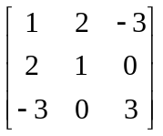)
To find out the j^{th} (j =1,2…n-1) matrix, Pj:
- Take the j^{th} column of the matrix P_{j-1}P_{j-2}…P₂P₁A (for j =1, use 1st column of A) and normalize it to have unit L₂ norm. Denote this vector by {x}. For the given matrix, for the first matrix P₁:
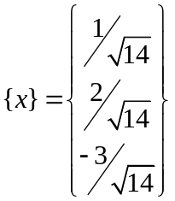
- Compute the L₂ norm of the subspace of {x} spanning the dimensions j through n, i.e., 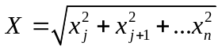(use the negative root if x_{j}>0). Define a new vector {y}, of unit magnitude, which has its first j-1 components as zero, the j^{th} component as 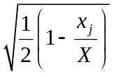and other components (k=j+1 to n) as 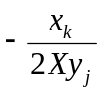.
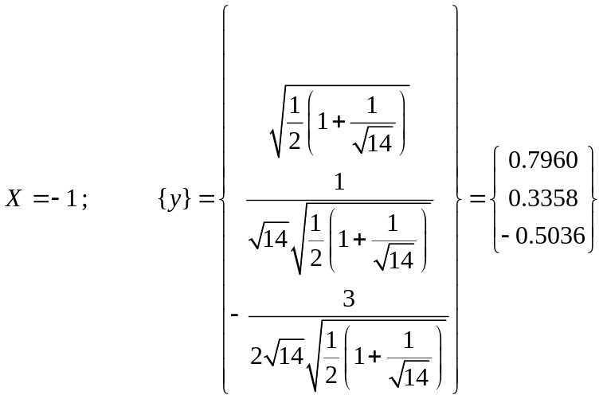
- Obtain the matrix P_{j} as 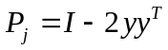
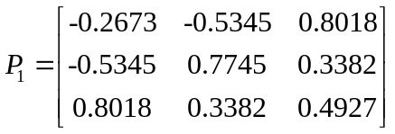
Repeating the steps 1, 2, and 3:
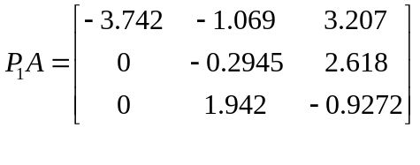

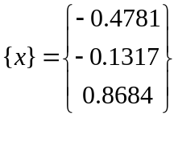
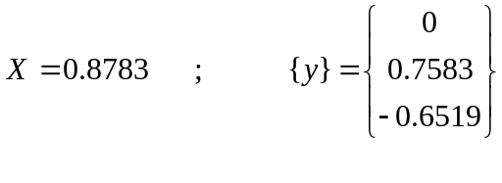
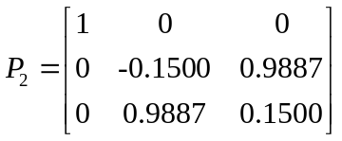
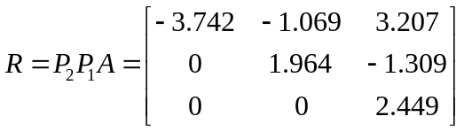
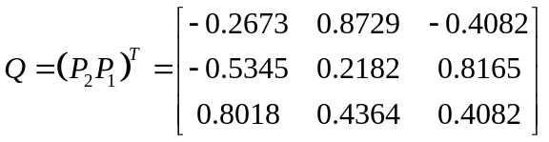
Using this technique of factorization and after about 15 iterations of the QR method, we get a diagonal matrix showing the Eigenvalues as 5.496, -2.074, and 1.578 (an Excel file showing the factorization technique and first few QR iterations may be seen at http://home.iitk.ac.in/~rajeshs/QR.xls).
Some remarks (we assume that all eigenvalues are real!):
1. For a 2x2 [A] matrix, Q is always symmetric.
2. For 3x3 and higher, in general Q will not be symmetric even when A is symmetric.
3. If all the eigenvalues are distinct, the final [A] matrix would be diagonal for symmetric matrices, and upper triangular for non-symmetric matrices.
4. Convergence of QR method is slow if two eigenvalues are very close.

Fourier Series

Orthoganility:
Continuous:
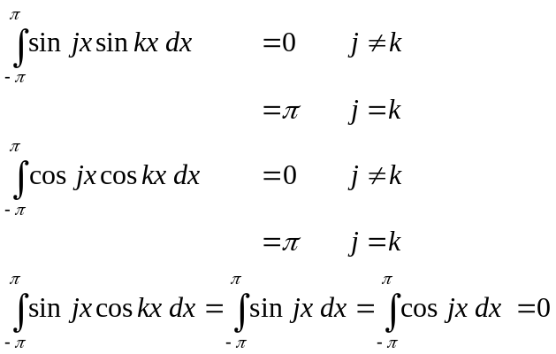
OR, in term of the exponentials
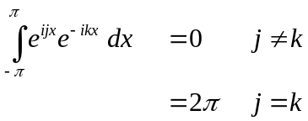
Discrete:
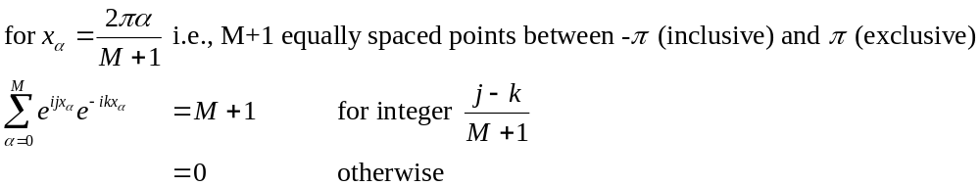
Fourier Expansions:
Continuous: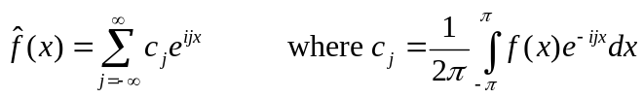
OR:

Discrete: (one time period is divided into M+1 intervals, the last point is not considered since it will be same as the first point due to periodicity)
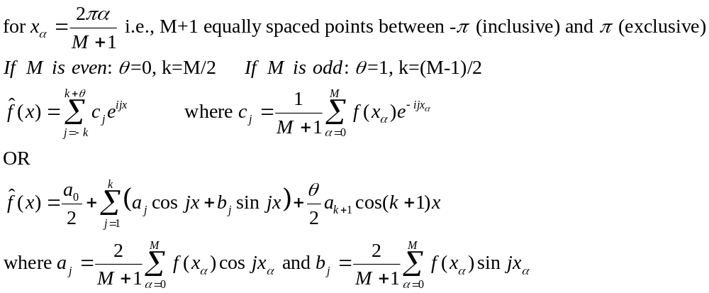
Note that the form given above results in interpolation with 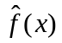equal to f(x) at all the (M+1) grid points. Fewer terms could be used (i.e., summation not carried up to 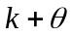) to obtain a least squares fit. The j=1 term is the fundamental frequency and j=2 is the first harmonic.
Also note that (i) the textbook uses a “time period” of T, while we have used 2π in the class. Therefore, while the book has the fundamental frequency as 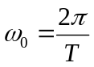 for the continuous case, we have 1 (ii) the discrete approximation given in the book requires complex computations while that given above in terms of sine and cosine does not (although they are equivalent).

Legendre Polynomials

Definition: 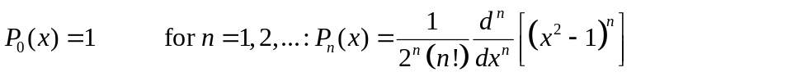
Orthogonality: 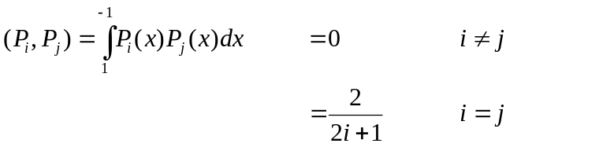

Recursion:
The equivalent polynomials for discrete data are Gram’s polynomials.

Following is a plot of the Legendre Polynomial approximation of f(x)=1/(1+x²) using up to orders 0, 2, 4, and 8. Note the “general” improvement in fit with increasing order. However, for a specific point the error may increase for a higher order fit (e.g., near x=0.5, order 0 fit is better than 2nd order fit).

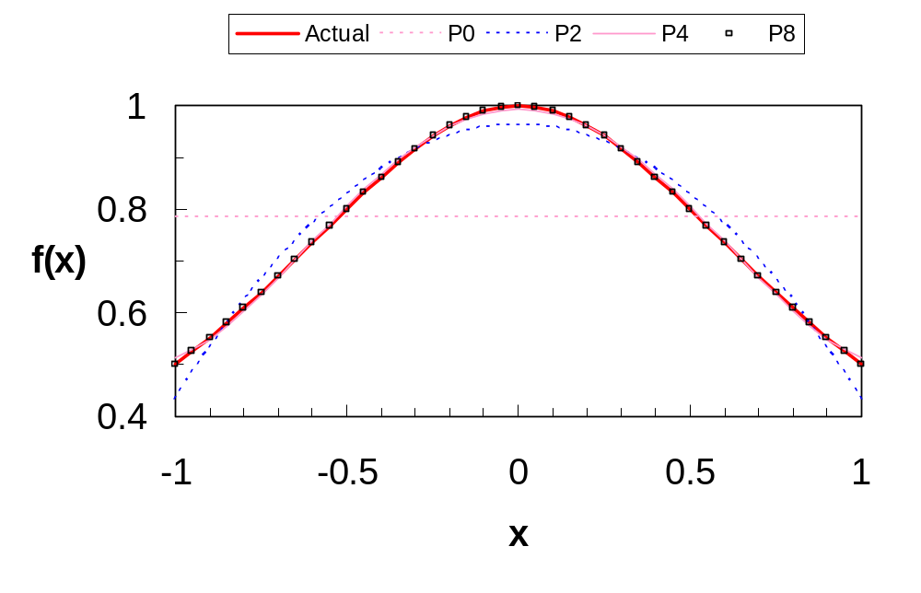
Tchebycheff Polynomials

Definition: 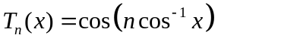
Orthogonality :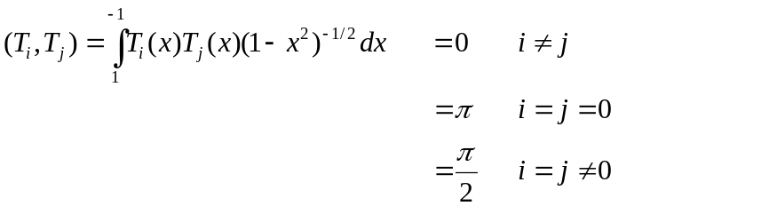

Recursion:
In the interval [-1,1],
n Zeroes of 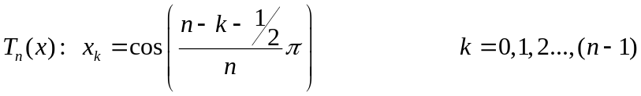
(n+1) extrema 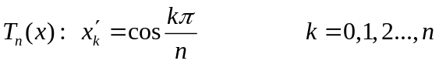 Values of T_{n}(x) are (-1)^{k}.

Following is a plot of the Tchebycheff Polynomial approximation of f(x)=1/(1+x²) using up to orders 0, 2, 4, and 8. Note the “general” improvement in fit with increasing order. However, for a specific point the error may increase for a higher order fit (e.g., near x=0.65, order 0 fit is better than 2nd order fit).

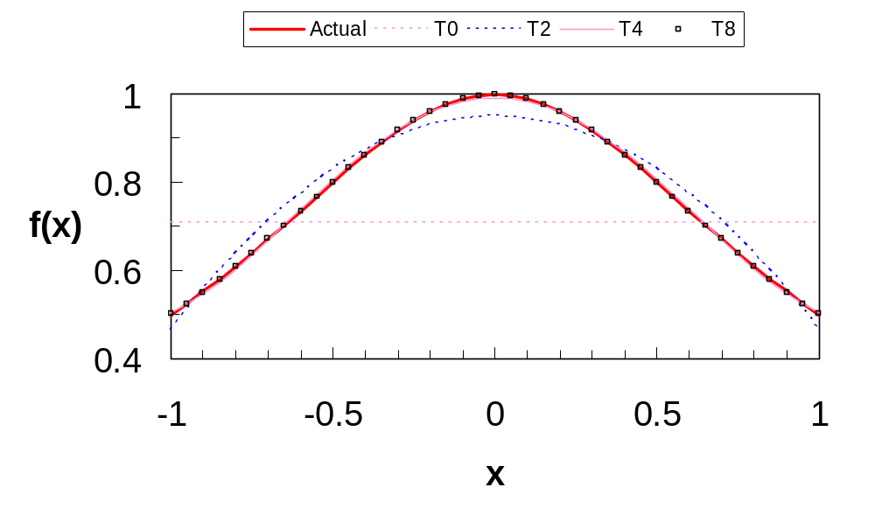
Tchebycheff Polynomials For discrete case:

If x_{k} are the zeroes of T_{m+1}(x) and the range of i and j is from 0 to m:
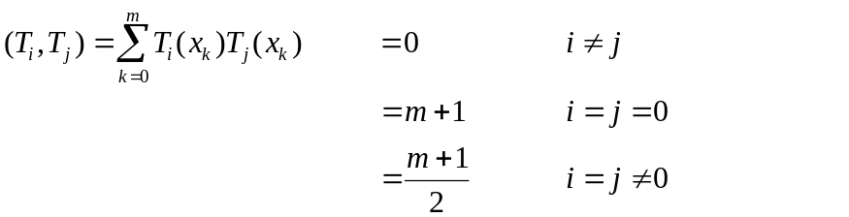
Cubic Splines

Using the local coordinate system for the i^{th} segment, 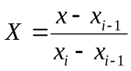and using the symbol Δ_{i} to represent (x_{i}-x_{i-1}), we get (starting from the fact that the second derivative is linear)

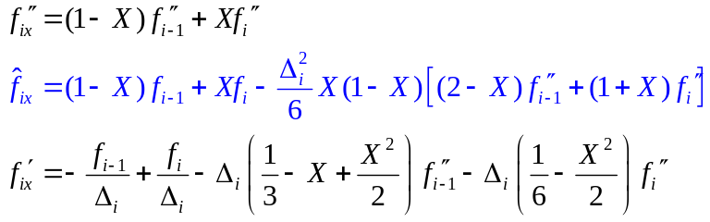
Continuity of the first derivative gives us
which along with the two end conditions 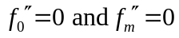 could be solved using the Thomas algorithm for tridiagonal system.

Starting from the first derivative, which is a quadratic function of x, we get (after using the two end conditions for the first derivative and an unknown constant C₁)

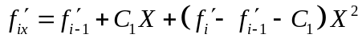

Integrating once to obtain the cubic polynomial and applying the two end conditions for the function values, we get

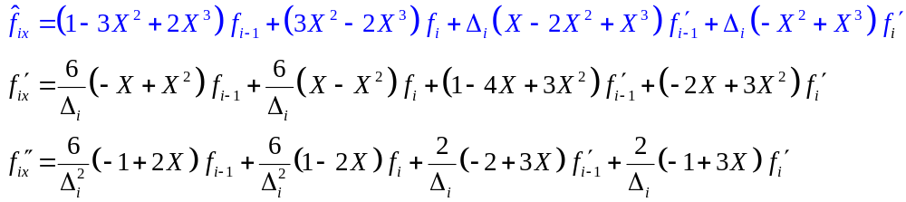

Continuity of the second derivative gives us
The two end conditions give the other two equations as
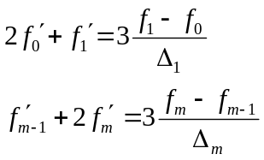
If we denote the “slope” of the data points as 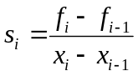, we may write these equations as
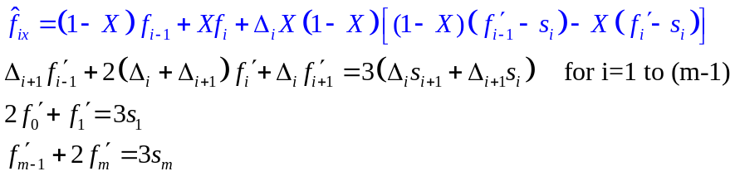
Gram’s Polynomial

The general equation for generating Gram’s polynomials of order m for equidistant points between -1 and 1 (x_{i} = -1 + 2i/m for i=0 to m) is
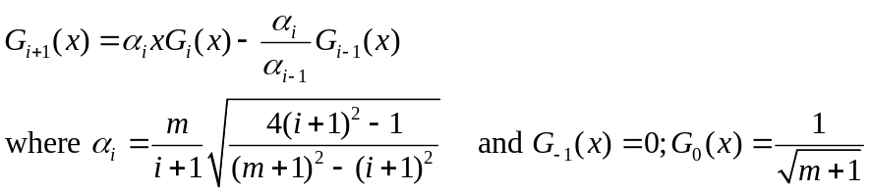
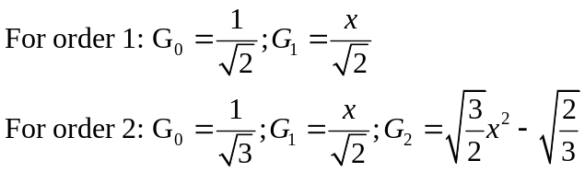
The interpolation formula is then given by
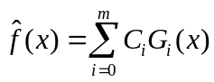
and the coefficients are obtained from the orthogonality property as
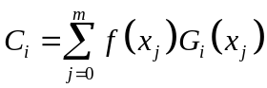
For example, for m=2, the coefficients are given by
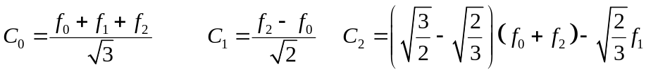

Vector and Matrix Norms

L_{p} norm of an n-dimensional vector, x, is given by:
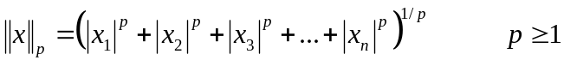
p=2 is the Euclidean norm and p→ ∞ denotes the maximum norm. The properties of Vector and matrix norms are (x, y are vectors, A, B are matrices and α is a scalar)
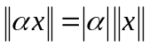
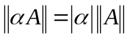
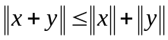
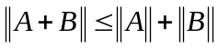

Also, for any vector norm there exists a “consistent” matrix norm such that
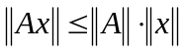
Similar to the Euclidean norm of a vector there is the Frobenius norm for a matrix defined by 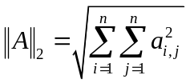. The norm which is easy to compute and is therefore commonly used is the maximum norm (also called uniform norm) which, for a vector, is the element with largest magnitude and, for a matrix, is the largest row-sum of absolute values, i.e., 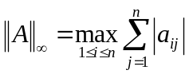. As shown in the class, for a linear system of equations Ax=b,
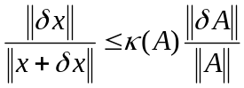
where κ(A) is the condition number of the matrix A and is equal to 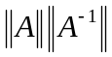. It can also be shown that 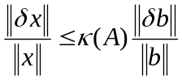. Thus for large condition numbers, small (relative) changes in A or b will produce large (relative) change in x.

Convergence Properties of the Newton-Raphson Method

As discussed in the class 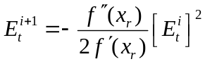indicating quadratic convergence.
If we assume that for all points x_{a} and x_{b} “near” the root, 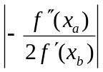 has an upper bound of M, we can write 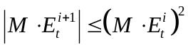. Now if we assume that the initial guess x₀ is sufficiently near the root AND 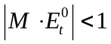, it can be shown that the iterations will converge and
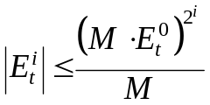
So, the N-R method will always converge if the initial guess is sufficiently close to the (simple) root AND magnitude of (M E_{t}⁰) is less than 1. However, since the root is not known beforehand it is difficult to use this criterion.

A more usable criterion for convergence is:
If there is an interval [l,u] such that f(l) and f(u) have opposite signs; f’(x) is not zero and f”(x) does not change sign in the interval; and |f’(x)/f(x)| at both l and u is less than (u-l); the N-R method will converge from any initial guess within the interval.

Error in the Method of False Position

For solving y=f(x)=0, it can be shown that after a sufficient number of iterations, one end of the interval remains fixed. If we take this fixed point as x₀, we have
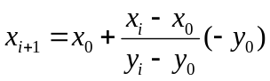
which is identical to Newton’s divided difference linear interpolation of function x=g(y) to obtain x for y=0. The error of interpolation is given by (x_{r} is the root)
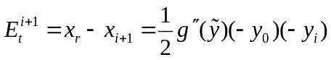
whereis in the interval (y₀,y_{i}). Using mean value theorem between x_{r} and x to obtain y and using 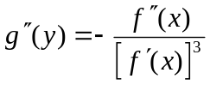, we may write
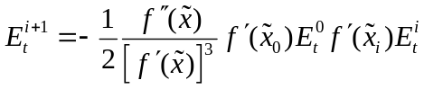
where is in the interval (x₀,x_{i}), 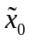is in the interval (x₀,x_{r}) and 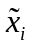is in the interval (x_{i},x_{r}). Assuming that the iterations converge to the root x_{r}
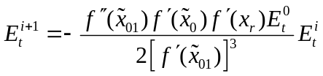
where 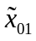is in the interval (x₀,x_{r}). This shows linear convergence.
Error in the Secant Method

For this method, we have
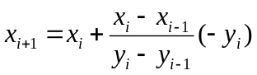
The error of interpolation is given by (x_{r} is the root)
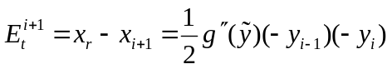
whereis in the interval (y_{i-1},y_{i}). Again, we may write
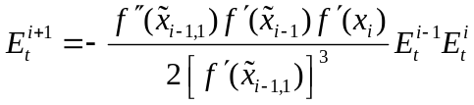
where both 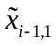and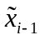 are in the interval (x_{i-1},x_{r}), and is in the interval (x_{i},x_{r}).
Assuming that the iterations converge to the root x_{r}, we get, for large i,
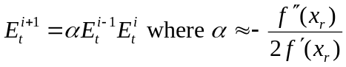
If p denotes the order of the Secant method and C its asymptotic error constant (such that asymptotically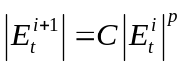) we get p²=p+1 and C=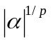implying that the order is 1.618 (better than Bisection and False Position but not as good as Newton Raphson). As far as efficiency is concerned, if the computational effort in evaluating the derivative of a function is more than 0.44 times that required for a function evaluation, the Secant method is preferred (1.618^{1.44}=2)

Error in the Muller’s Method

For this method, since we use quadratic interpolation to find x for y=0, the error of interpolation is given by (x_{r} is the root)
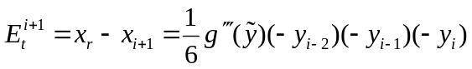
whereis in the interval (y_{i-2},y_{i-1},y_{i}). Again, assuming that the iterations converge to the root x_{r}, we may write
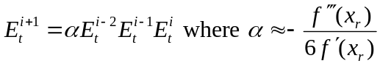
If p denotes the order of the Muller method, we get p³=p²+p+1 implying that the order is 1.839 (better than Secant but not as good as Newton Raphson).

